Filtering/Refinement

Overview
- Refinement is a feature that allows search results to be filtered into predefined categories
- In the example below, users can decide to Undergraduate Programs, Graduate Programs, Certificates, Diplomas, or all results relating to business
  - But they can only view one tab at a time

Demonstration
- Go to any page with the Google Custom Search bar
- Type in anthropology and press Enter or click on the red search button on the right
- Every page pertaining to anthropology will be searched

- See below for a sample screenshot of the search results
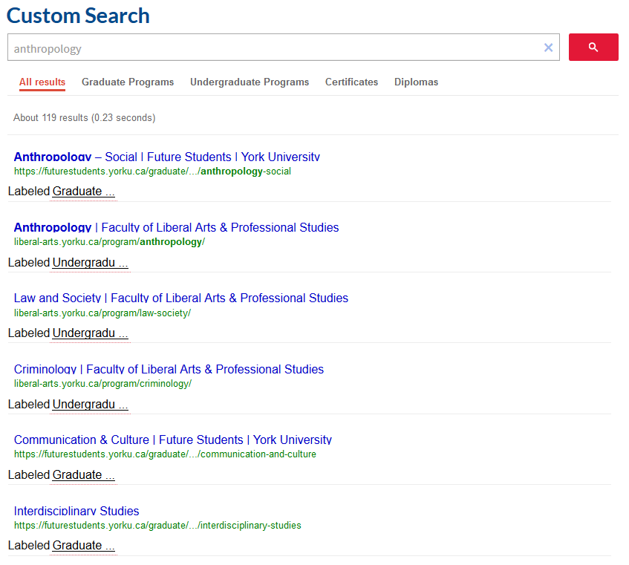

- In the tabs (just below the search bar), click on Undergraduate Programs
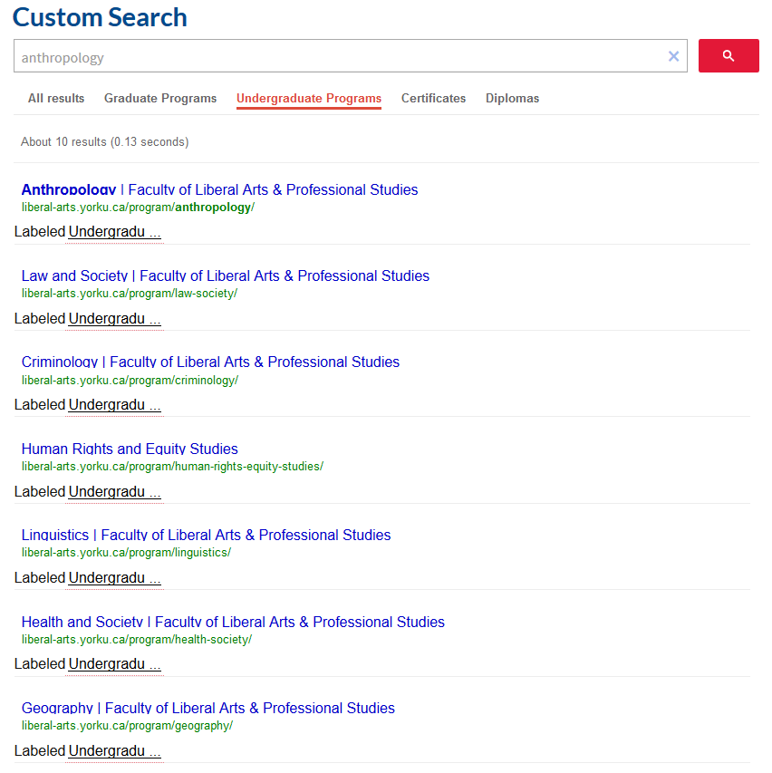
- The search results are now filtered by undergraduate programs
- You can confirm this by observing that every entry is Labeled Undergraduate
- You can also confirm, by visiting every page but I don’t really recommend it

- Now click on Graduate Programs at the top
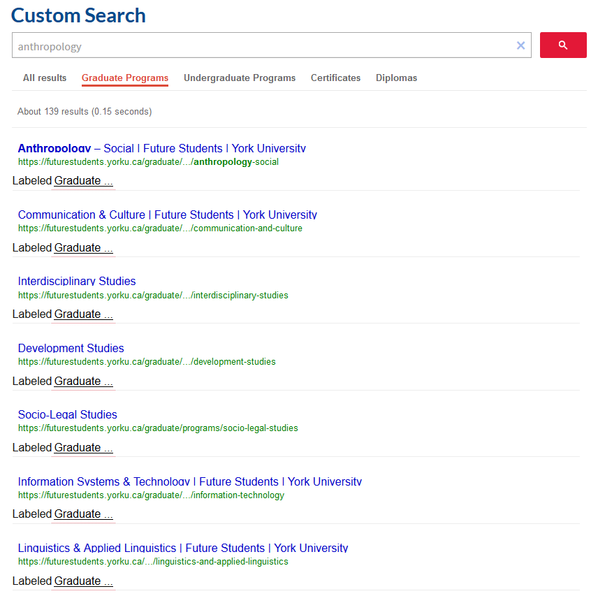
- As you might expect, all search results are associated with graduate programs

Autocomplete

Overview
- Autocomplete is a feature where Google gives suggestions on search keywords based on what you have typed
- The suggestions will start showing up as soon as you start typing

Demonstration
- Go to any page with the Google Custom Search bar
- Start typing commerce
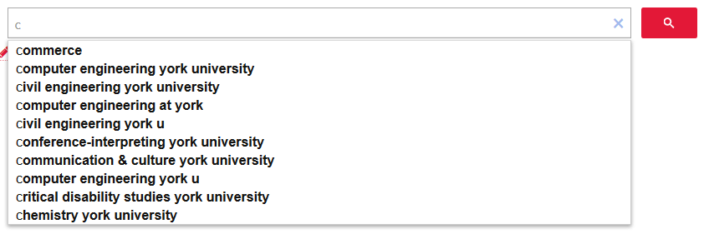
- If you are unsure of what you are looking for, you should enter more text to get more specific suggestions
- The more you type, the more refined the suggestions will be
